Living Active Dementia
Active Living Mentoring

Why stay active?
Prevent Falls
Increase Cognition
Better Mood
Increase Self Confidence
Better Immunity
Why NOT stay active?!

Living Active Dementia will make:
Suggestions on Adaptations to make it Successful!


Suggestions on best ways to Motivate!

Suggestions on best ways promote positive and fun times!
If you don’t use it, you will lose it

Caregiver Stress is Real!
Learn tips to keep it at bay from Living Active.

Living Active Dementia includes Wellness Techniques in every assessment learned in my 22 years of Healthcare Background

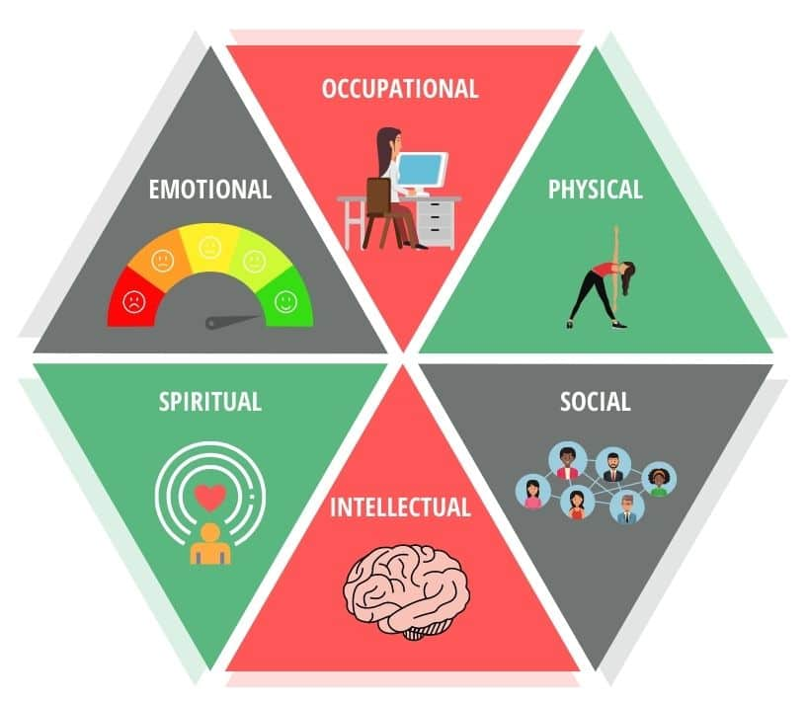


Empathetic, Good Listener, Advocate, Passionate – words used to describe Living Active Services

Virginia Simmons Living Active Dementia Caregiver Coaching Tel 434-907-6190
www.LivingActiveDementia.com Livingactive22@gmail.com
Call for an appointment today

Veterans qualify for a 10% Discount with a One Hour Session

