Living Active Dementia

Active Living – Tips for Aging Well

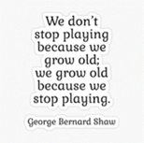
Stay Healthy
Open Communication with Your Doctor/Medical
Practice Drug Safety
Healthy Diet Choices
Stay Active – Physically, Socially, Mentally

Stay Safe
Use Technology Safely – know about scams and computer safety
Crime Safety – doors & windows locks, alarm systems, safety in numbers
Prevent Falls – maintain physical abilities, vision, know Rx side effects
Bright lighting, use rails (stairs, bathroom, sidewalks), Decrease clutter
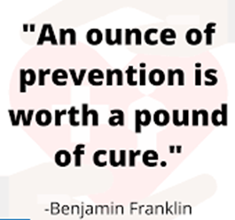

Stay Connected
Go out with others
Talk with others on phone
FaceTime connections through internet
Stop Depression – its ok to ask for help
Realize you are not alone
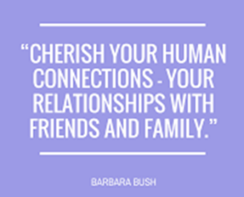

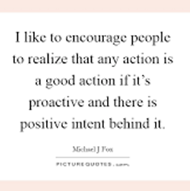
Stay Positive
Happiness - pursue goals better, cope with setbacks better
Positive - expect good things, positive coping strategies
Proactive - have a plan, control the outcome, prepare for situations
Change is the only constant, focus on what you can control

Why Active Living?
Stay Independently Longer
Better Quality of Life
Increased Enjoyment & Happiness
Free Verbal Assessment
Give me a Call and Leave a Message!

Virginia Simmons Living Active Dementia Consulting and Training Tel 434-907-6190
Livingactive22@gmail.com

