1 in every 5 falls causes serious head injuries

Less than ½ tell their doctor

Living Active Dementia

Home Safety Services

**Home Safety Assessments with**

**Living Active Dementia can greatly reduce falls!**

Baby Boomers are starting to turn 65

12% can have a Mild Cognitive Impairment (MCI)

**Fall prevention is one of the best ways to keep MCI at bay!**

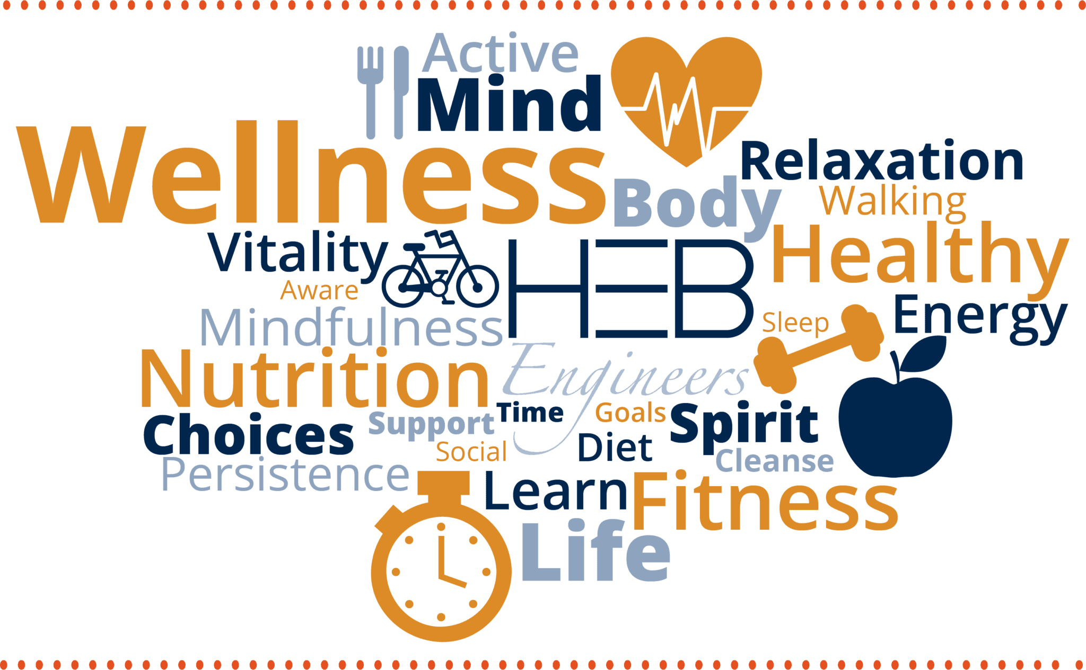

Home Assessments can find hidden dangers

**Living Active Dementia includes**

**Wellness Techniques and Hazard Awareness in every assessment learned in my 22 years of Healthcare Background**

Strengths and weaknesses of your loved ones will be incorporated in each Home Assessment to personalize the experience.

**Empathetic, Good Listener, Advocate, Passionate – words used to describe Living Active Services**

Veterans qualify for a 10% Discount on a Full Assessment.

**Virginia Simmons Living Active Dementia Caregiver Coaching Tel 434-907-6190**

**www.LivingActiveDementia.com Livingactive22@gmail.com**

Call for an appointment today