1 in every 5 falls causes serious head injuries
Less than ½ tell their doctor

Living Active Dementia
Home Safety Services
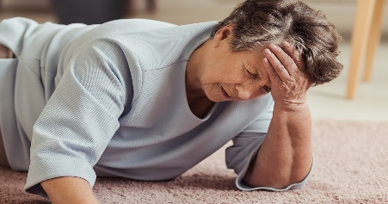

Home Safety Assessments with
Living Active Dementia can greatly reduce falls!

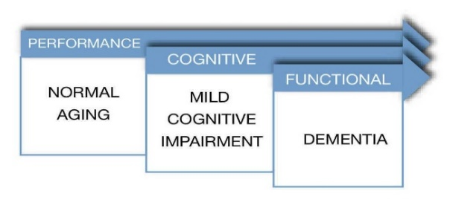
Baby Boomers are starting to turn 65
12% can have a Mild Cognitive Impairment (MCI)

Fall prevention is one of the best ways to keep MCI at bay!

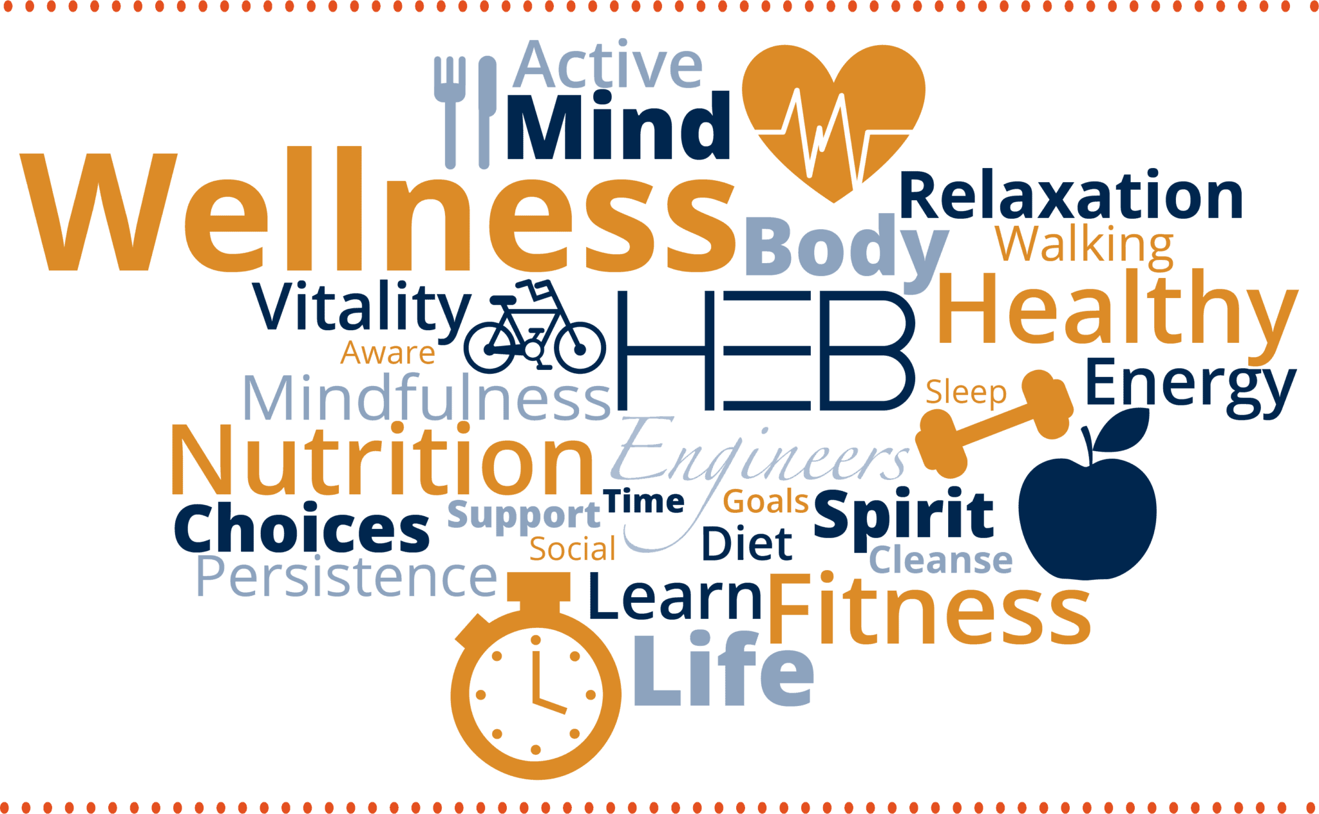
Home Assessments can find hidden dangers

Living Active Dementia includes
Wellness Techniques and Hazard Awareness in every assessment learned in my 22 years of Healthcare Background

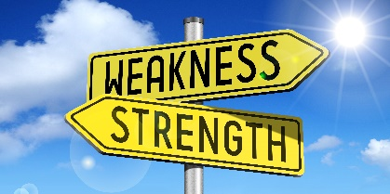

Strengths and weaknesses of your loved ones will be incorporated in each Home Assessment to personalize the experience.

Empathetic, Good Listener, Advocate, Passionate – words used to describe Living Active Services

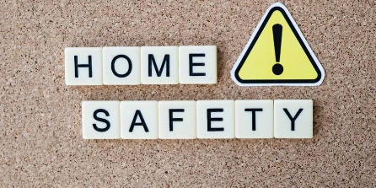

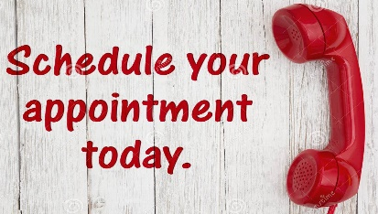
Veterans qualify for a 10% Discount on a Full Assessment.
Virginia Simmons Living Active Dementia Caregiver Coaching Tel 434-907-6190
www.LivingActiveDementia.com Livingactive22@gmail.com
Call for an appointment today

