New to this Journey? Where to start? Where to go? Living Active can Help!

58 million Americans are 65 years and older.

10 million Americans are Caregivers to Elderly Loved Ones.

Living Active Dementia

New to Elder Caregiving

25% are Sandwich Generation Caregivers

= you take care of a child and a parent.

Are you juggling with both worlds?

Living Active Dementia can help with tips on how to combine the two together!

**Caregiver Stress is Real!**

Learn tips to keep it at bay from Living Active.

Review the basics of Need to Know Information

when you care for your elderly loved one:

**Paperwork? Finances? Medical? Social?**

Living Active Dementia can help!

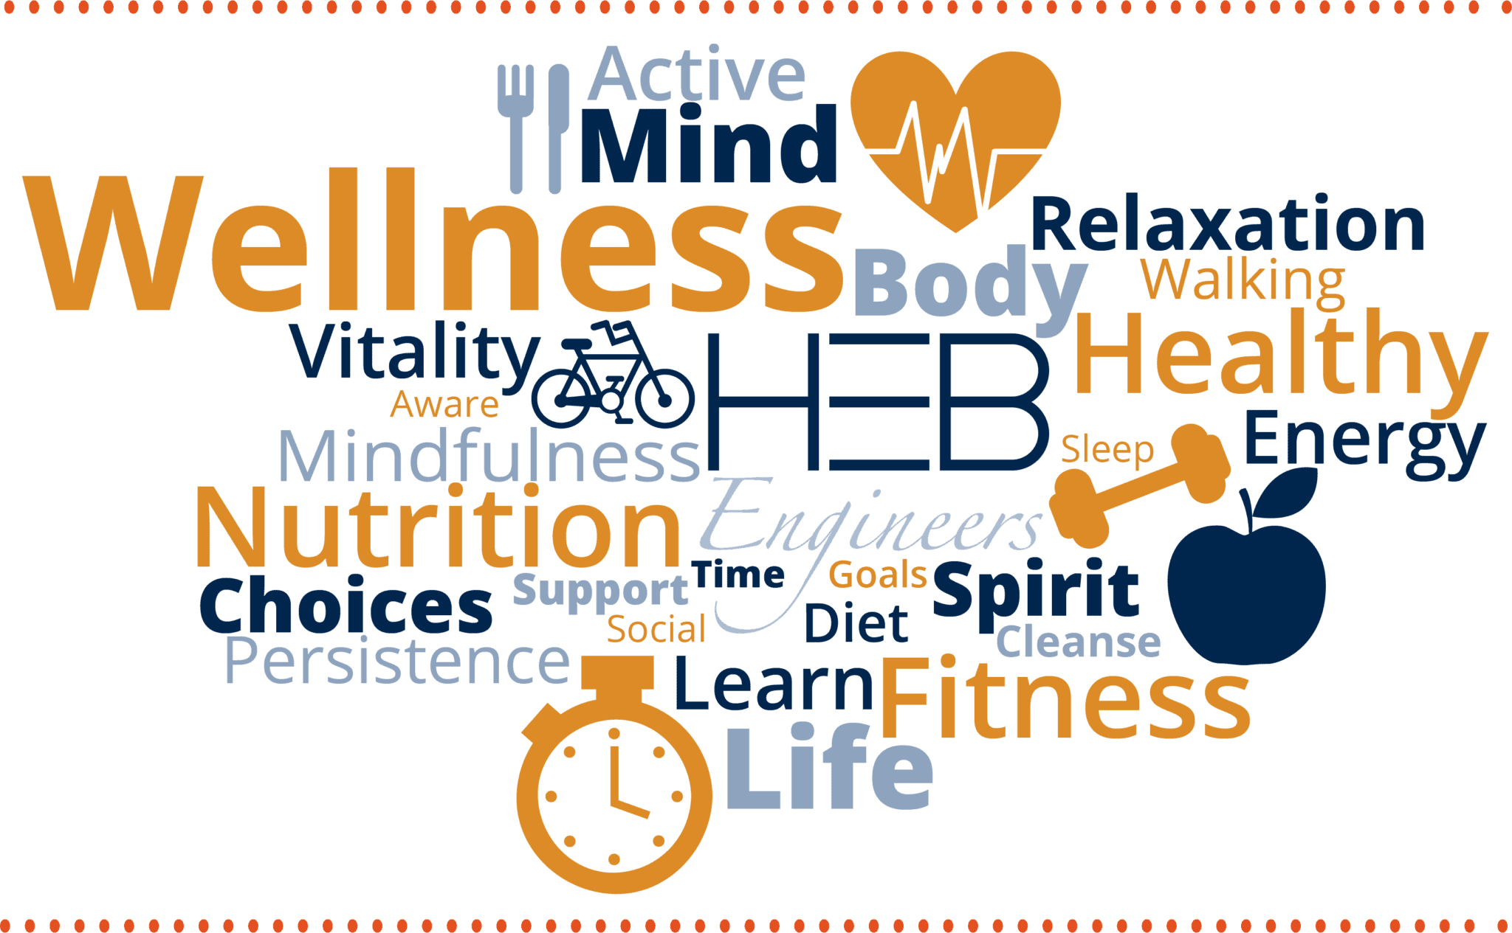

**Living Active Dementia includes**

**Wellness Techniques in every assessment learned in my 22 years of Healthcare Background**

**Empathetic, Good Listener, Advocate, Passionate – words used to describe Living Active Services**

Veterans qualify for a 10% Discount on a One Hour Session

**Virginia Simmons Living Active Dementia Caregiver Coaching Tel 434-907-6190**

**www.LivingActiveDementia.com LivingActive22@gmail.com**

Call for an appointment today