New to this Journey? Where to start? Where to go? Living Active can Help!
58 million Americans are 65 years and older.
10 million Americans are Caregivers to Elderly Loved Ones.
Living Active Dementia
New to Elder Caregiving

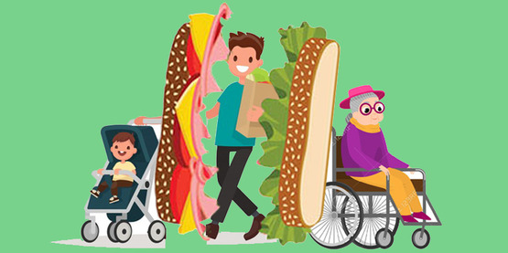
25% are Sandwich Generation Caregivers
= you take care of a child and a parent.

Are you juggling with both worlds?
Living Active Dementia can help with tips on how to combine the two together!

Caregiver Stress is Real!
Learn tips to keep it at bay from Living Active.
Review the basics of Need to Know Information
when you care for your elderly loved one:
Paperwork? Finances? Medical? Social?
Living Active Dementia can help!

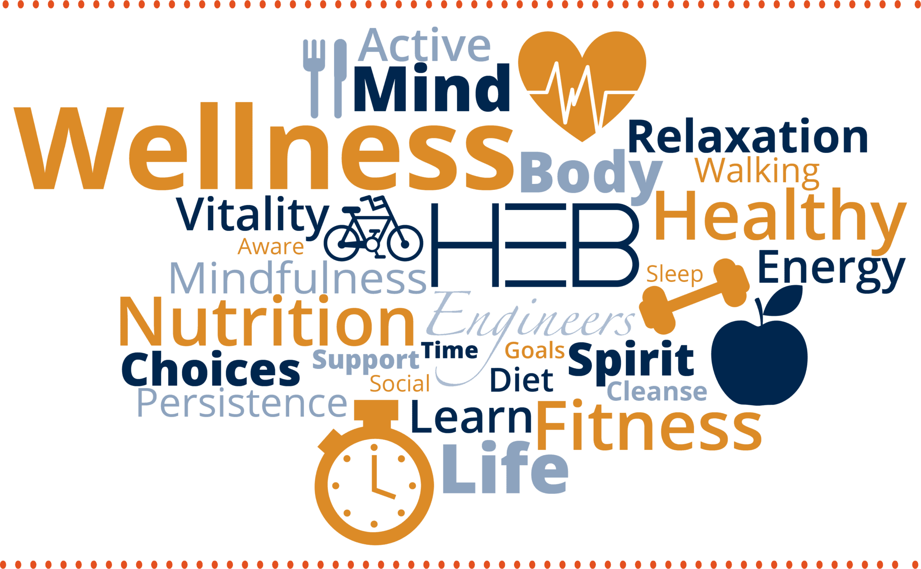
Living Active Dementia includes
Wellness Techniques in every assessment learned in my 22 years of Healthcare Background


Empathetic, Good Listener, Advocate, Passionate – words used to describe Living Active Services

Veterans qualify for a 10% Discount on a One Hour Session

Virginia Simmons Living Active Dementia Caregiver Coaching Tel 434-907-6190
www.LivingActiveDementia.com LivingActive22@gmail.com
Call for an appointment today

